Figures
The compliance distributions mirror the baseline case, with compliant FBOs remaining relatively stable and only minor fluctuations in compliance level 2 FBOs in the tuned risk-based inspection scenario. In contrast, the equal weight risk-based method occasionally shows slightly more transitions towards worse compliance level than the random scenario.

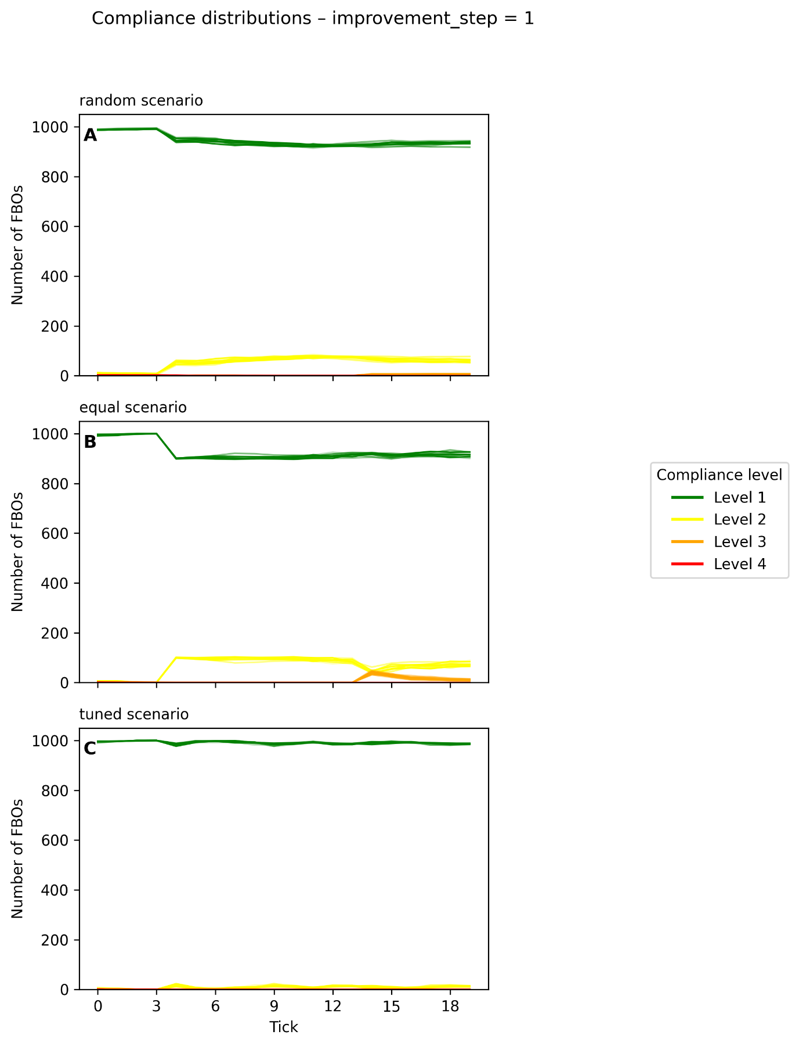
Figure 1 Compliance distribution – baseline (deterioration step = 0.1; improvement step = 1)

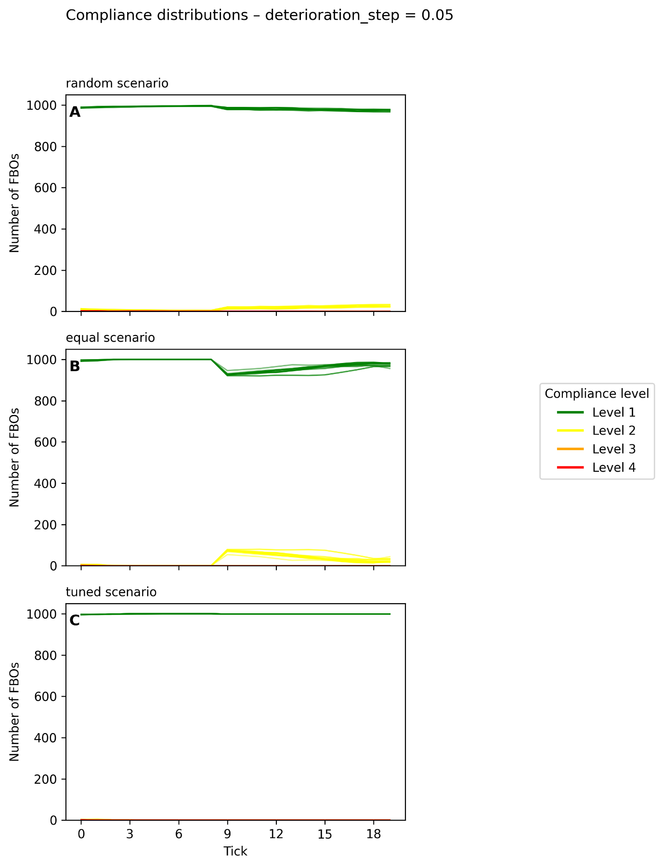
Figure 2 Compliance distribution – deterioration step = 0.05

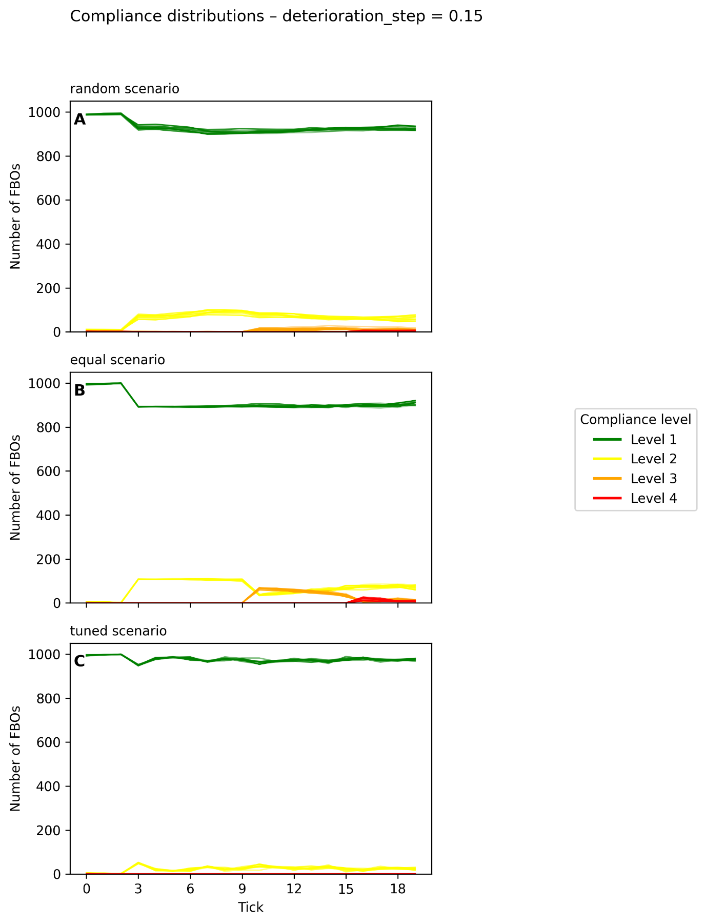

Figure 3 Compliance distribution – deterioration step = 0.15
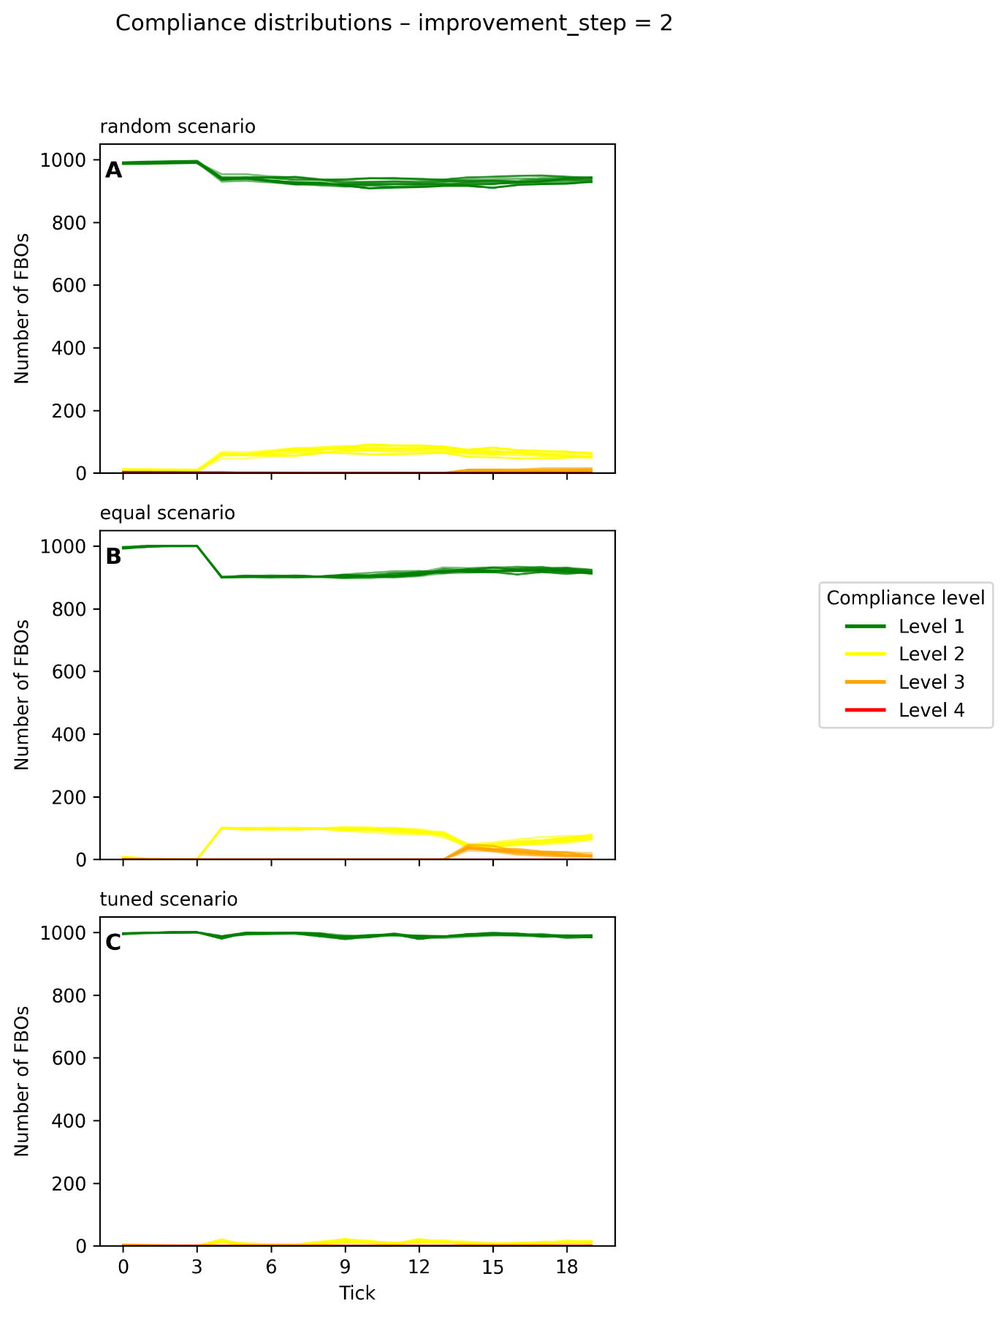
Figure 4 Compliance distribution – improvement step = 2

